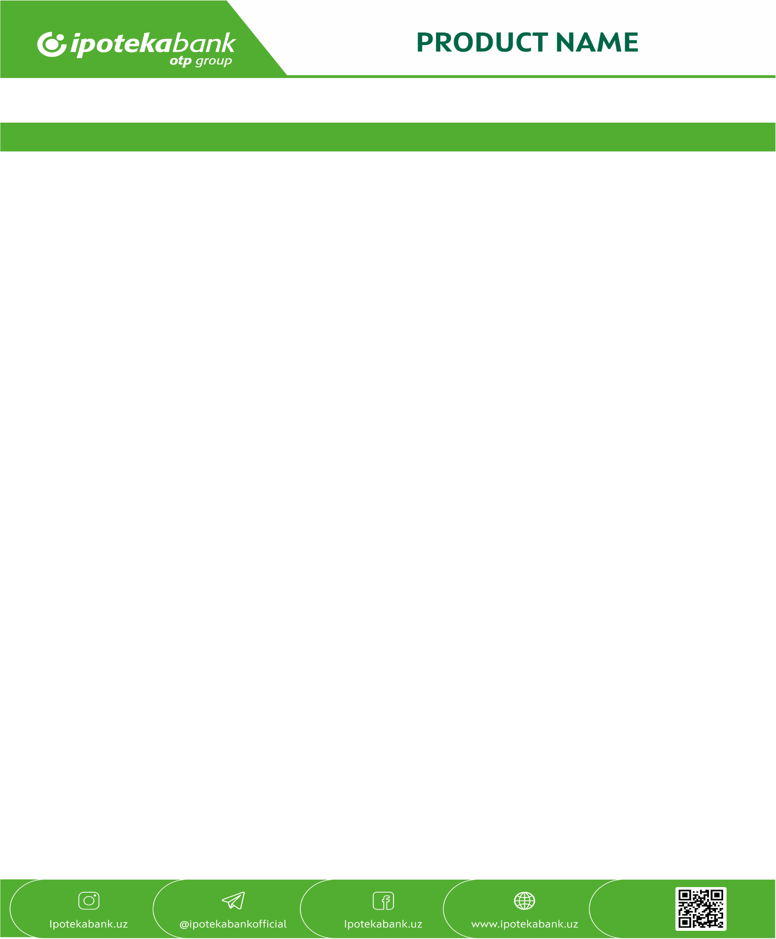
Structured deposit

Product for Corporate Business

Type of deposit | Term deposit “Premium”
Design object | Funds are accepted from a current/secondary account
Deposit currency | In national and foreign currency
Deposit tenor | By agreement of the parties
Minimum deposit amount | Unlimited
Maximum deposit amount | Unlimited
Annual percentage rate (contractual interest rate) | Determined individually in accordance with the bank’s internal rules.
The procedure for calculating interest | Interest on the amount of a bank deposit is accrued from the next day of receipt of the deposit by the bank until the day preceding its return to the depositor or withdrawal from the depositor's account for other reasons (Civil Code of the Republic of Uzbekistan, Article 764)
Payment of interest income | Accrual is calculated automatically every day, payment is made on the first day of the next month
Capitalization | No
Early return of deposit or partial withdrawal | Determined individually in accordance with the bank’s internal rules.
Deposit refund at the end of the term | The deposited funds are credited to the account until they are requested after the tenor has expired (minus the amount of tax established by law for budgetary organizations).
Registration procedure | By concluding a Deposit Agreement
Minimum deposit balance | 10% of the deposit amount (does not apply to cases of full early return)
Clients | Corporate clients of JSCMB "Ipoteka-bank" and other banks clients

